**Performance Evaluation**

|  |  |  |  |  |  |  |  |  |  |  |  |  |  |  |  |  |  |  |  |  |  |  |  |  |  |  |  |  |  |  |  |  |  |  |
| --- | --- | --- | --- | --- | --- | --- | --- | --- | --- | --- | --- | --- | --- | --- | --- | --- | --- | --- | --- | --- | --- | --- | --- | --- | --- | --- | --- | --- | --- | --- | --- | --- | --- | --- |
| |  | | --- | | 10000 Requests (Nr/Nw) | | Write Heavy | | Read Heavy | | 80% Write 20% Read | | 50% Write 50% Read | | 20% Write 80% Read | | |  | | --- | | (4/4)  Time (ms) | | 147997 | | 63008 | | 127979 | | 97468 | | 72122 | | |  | | --- | | (3/5)  Time (ms) | | 226881 | | 64841 | | 183821 | | 132761 | | 87906 | | |  | | --- | | (2/6)  Time (ms) | | 269053 | | 55204 | | 217419 | | 151993 | | 75905 | | |  | | --- | | (1/7)  Time (ms) | | 278255 | | 47122 | | 220642 | | 160527 | | 87528 | |

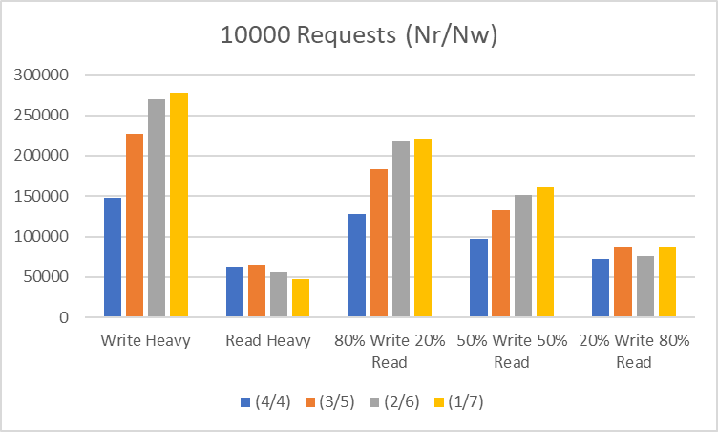

The performance evaluation of the system was carried out for a total of 10000 requests over different values of Nr and Nw. The number of servers connected was fixed at N=7.

The different cases of Nr/Nw are 4/4 , 3/5, 2/6, 1/7

The varying workloads evaluated are Read Heavy (with 10000 read requests), Write Heavy (with 10000 write requests), 80% Write 20% Read (with 8000 write requests and 2000 read requests), 50% Write 50% Read (with 5000 write requests and 5000 read requests) and 20% Write 80% Read (with 2000 write and 8000 read requests).

As we can see from the above plot on increasing Nw, the execution time in ms also increases except the read heavy case.

**From the above graph we can see that  
 read heavy** operation takes less time with decrease of NR .Because it has to read from less no of nodes with the decrease in nr which will be provided by the quorum.  
 **Write Heavy** operation takes more time with increase in Nw.Since the write will be performed in Nw nodes (provided by the quorum).And it will take more time with the increase in NW.  
  
**80%write20%read**:Since majority of the this operation belongs to writing We can see that it behaves same as write heavy operation.  
  
 **50% read 50%write**:Since 50 % of the operations are Write only and 50% read operation and since write operations are dependent on each other while read operations are not so it follows the same pattern as write operations since write operations takes more time than read operation.  
  
**20% write 80%read:**since most of the operations are read operations in this case and write operations takes more time compared to the read operations so it does not follow a monotonic pattern.

**Testcases**

**N=7 Nr=4 Nw=4**

**Here the assumption is** the values of NR and NW are subject to following two constraints:

1. NR + NW > N

2. NW > N/2

**Negative Testcases**

**1) 3 nodes joined**

**Output : System not ready!**

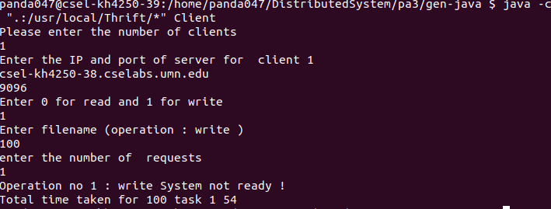

1. **(All nodes are up) Reading a file not present**

**Output : File Not Found**

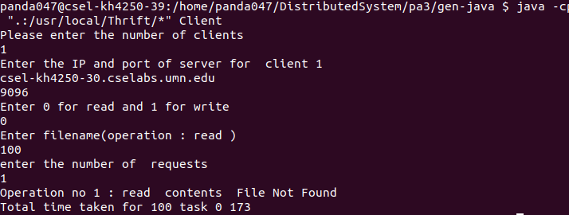

**Positive Testcases**

1. **Concurrent Write**

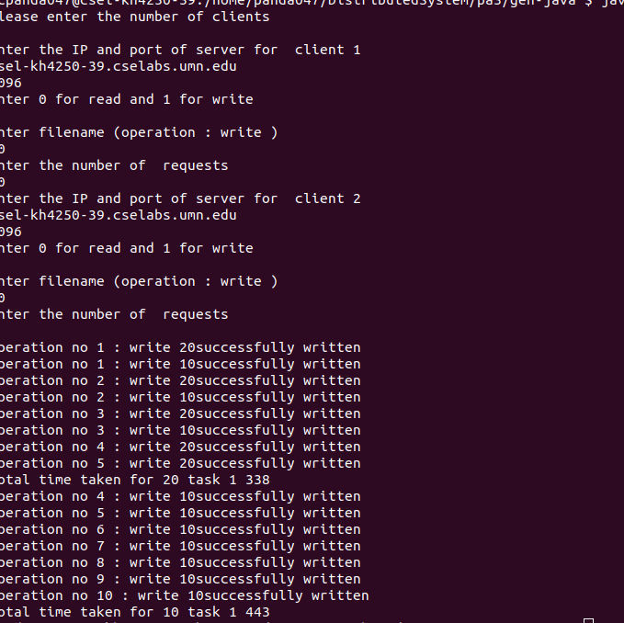

1. **Concurrent Read**

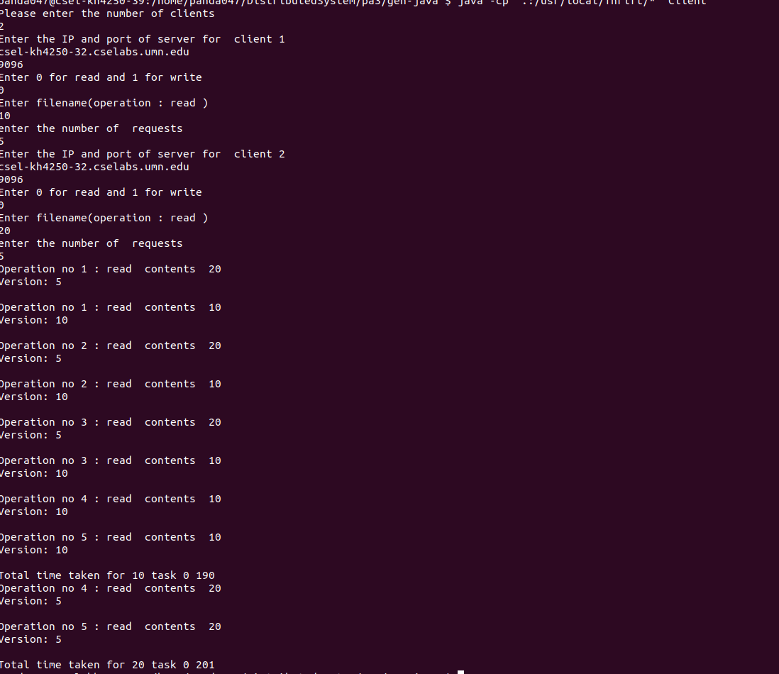

1. **Write Read Write**

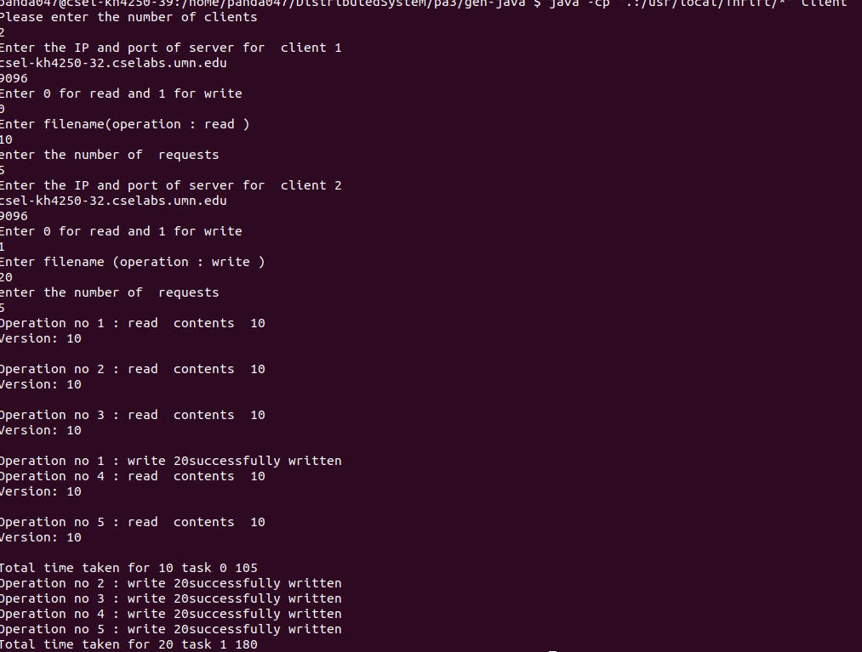

1. **Write Write Read**

